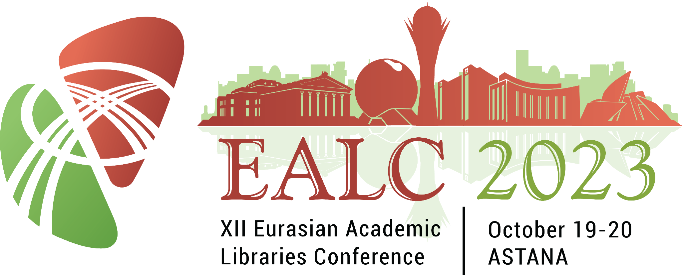

12th Eurasian Academic Libraries Conference (EALC)
2023 theme “Education 5.0: Challenges and Prospects for Academic Libraries”
(Nazarbayev University, Astana, Kazakhstan, 19-20 October 2023)

The Association of University Libraries of the Republic of Kazakhstan, the Ministry of Science and Higher Education of the Republic of Kazakhstan, and Nazarbayev University Library invite you to the 12th Eurasian Academic Libraries Conference (EALC) with the theme Education 5.0: Challenges and Prospects for Academic Libraries which will be held at Nazarbayev University (Astana, Kazakhstan) on 19-20 October 2023.
The EALC-2023 is intended to become a platform for the exchange of ideas, knowledge, and experience of academic libraries in support of Education 5.0 as a new stage of the global educational development devoted to a more human perspective to learning, including social and emotional abilities to turn digital transformation into a tool for social transformation and promote lesser environmental impact with greater health and safety. The Conference will feature distinguished researchers and engaging speakers that can provide a venue for scientific discussion, constructive exchange of ideas, and best practices through oral presentations.
We also extend our invitation to potential sponsors as exhibitors. As an exhibitor, you will enjoy exposure and direct marketing opportunities with practitioners and decision-makers in the field. Exhibitors may choose from different sponsorship packages: Gold, Silver, and Bronze. To know more about the sponsorship opportunities, please visit the EALC 2023 website.
This year, the Steering Committee is pleased to offer two (2) attendance grant opportunities for Kazakhstani librarians from regions of Kazakhstan outside Astana. To learn more about this grant opportunity, please visit the EALC website.
The languages of the conference are English, Kazakh, and Russian.
[ Conference site ] [ Registration ]

Call for Papers
The emergence of the new phase of industrialization known as the Fifth Industrial Revolution (Industry 5.0) calls for the educational system to keep pace with the changing demands of the time. Dubbed Education 5.0, this new stage of educational development focuses more on humans in many aspects to be more creative, innovative, and motivated. While technology is seen as a valuable tool, it acts more as an enabler to prepare future-ready individuals capable of standing the test of time.
The program committee invites paper submissions in the field to highlight these practices in a changing world. The topics include:
- Impact of Education 5.0 on Libraries;
- Artificial Intelligence (AI) in Libraries;
- Internet of Things (IoT)
- Industry 5.0 and Libraries;
- Education 5.0 and Society 5.0;
- Industry 5.0 and Information Ethics;
- Smart Libraries;
- Library and Librarian 5.0;
- Equality, Diversity, and Inclusivity in Libraries;
- Academic Libraries and UN Sustainable Development Goals (SDGs);
- Hybrid and Hyflex (hybrid flexible) Services in Libraries;
- Media and Information Literacy in Libraries
For more information on submissions, please visit the EALC 2023 website.
At the end of the conference, a general meeting of members of the Association of University Libraries in the Republic of Kazakhstan will be held.
For further inquiries, please contact us at ealc@nu.edu.kz.

Important Dates
Call for Papers | 5 April 2023
Full Paper Submission Deadline | 1 June 2023
Notification of Accepted Papers | 20 August 2023
Submission of Camera-Ready Full Papers and PowerPoint presentation | 30 September 2023
Start of Registration (for All) | 1 May 2023
Early Bird Registration | 5 April - 1 August 2023
End of Registration | 6 October 2023
Conference | 19-20 October 2023

